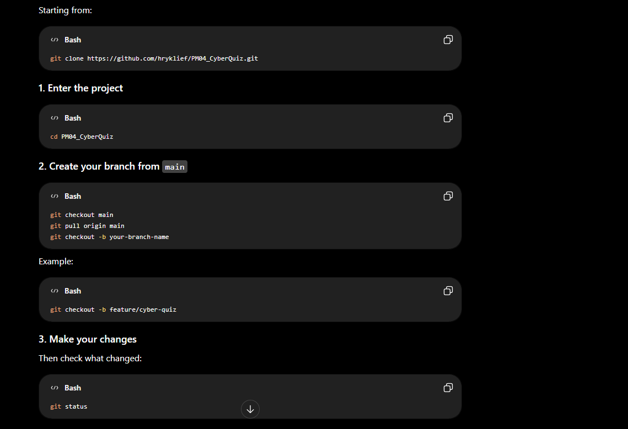

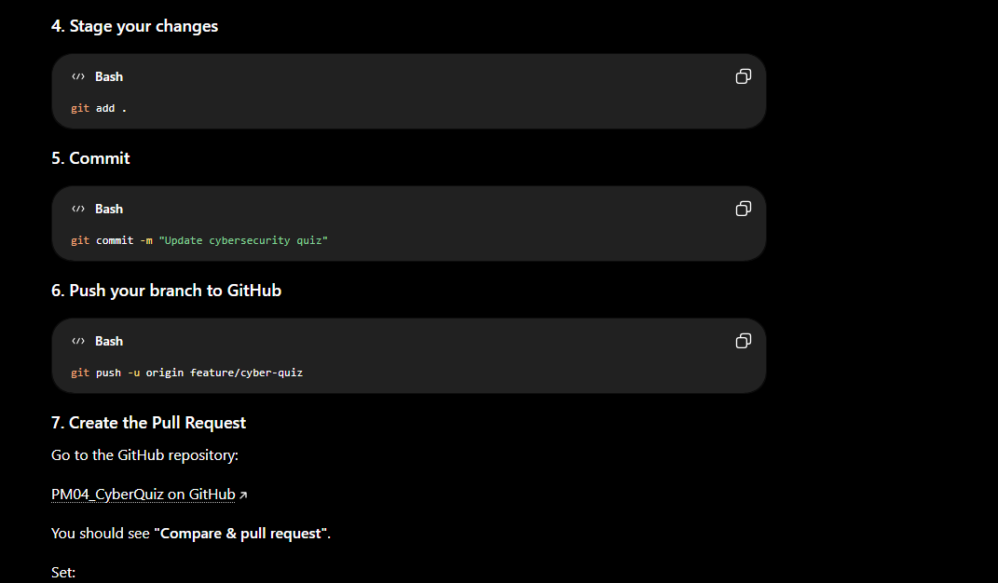

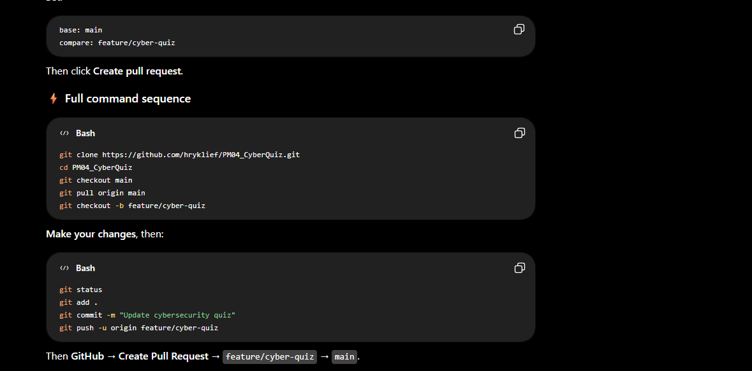

shaned@7H9F5H4-NB UCRT64 ~/OneDrive - Redpanda Software/Shane & Haroon - Dummy Demo
$ git clone git clone https://github.com/hryklief/PM04_CyberQuiz.git

shaned@7H9F5H4-NB UCRT64 ~/OneDrive - Redpanda Software/Shane & Haroon - Dummy Demo
$ git clone https://github.com/hryklief/PM04_CyberQuiz.git
Cloning into 'PM04_CyberQuiz'...
remote: Enumerating objects: 16, done.
remote: Counting objects: 100% (16/16), done.
remote: Compressing objects: 100% (16/16), done.
remote: Total 16 (delta 0), reused 16 (delta 0), pack-reused 0 (from 0)
Receiving objects: 100% (16/16), 192.29 KiB | 32.05 MiB/s, done.

shaned@7H9F5H4-NB UCRT64 ~/OneDrive - Redpanda Software/Shane & Haroon - Dummy Demo
$ cd PM04_CyberQuiz

shaned@7H9F5H4-NB UCRT64 ~/OneDrive - Redpanda Software/Shane & Haroon - Dummy Demo/PM04_CyberQuiz (main)
$ ls
Frontpage.html Login.html dashboard.html quiz.html results.html script.js
Images/ Readme.txt dashboard.js quiz.js results.js style.css

shaned@7H9F5H4-NB UCRT64 ~/OneDrive - Redpanda Software/Shane & Haroon - Dummy Demo/PM04_CyberQuiz (main)
$ git checkout main
git pull origin main
git checkout -b shane-dev
M script.js
M style.css
Already on 'main'
Your branch is up to date with 'origin/main'.
From https://github.com/hryklief/PM04_CyberQuiz
* branch main -> FETCH_HEAD
Already up to date.
Switched to a new branch 'shane-dev'

shaned@7H9F5H4-NB UCRT64 ~/OneDrive - Redpanda Software/Shane & Haroon - Dummy Demo/PM04_CyberQuiz (shane-dev)
$ git status
On branch shane-dev
Changes not staged for commit:
(use "git add <file>..." to update what will be committed)
(use "git restore <file>..." to discard changes in working directory)
modified: script.js
modified: style.css

Untracked files:
(use "git add <file>..." to include in what will be committed)
Readme.md
index.html

no changes added to commit (use "git add" and/or "git commit -a")

shaned@7H9F5H4-NB UCRT64 ~/OneDrive - Redpanda Software/Shane & Haroon - Dummy Demo/PM04_CyberQuiz (shane-dev)
$

shaned@7H9F5H4-NB UCRT64 ~/OneDrive - Redpanda Software/Shane & Haroon - Dummy Demo/PM04_CyberQuiz (shane-dev)
$ git add .
warning: in the working copy of 'Readme.md', LF will be replaced by CRLF the next time Git touches it

shaned@7H9F5H4-NB UCRT64 ~/OneDrive - Redpanda Software/Shane & Haroon - Dummy Demo/PM04_CyberQuiz (shane-dev)
$ git commit -m "Updated features"
[shane-dev e4624e4] Updated features
4 files changed, 2604 insertions(+), 228 deletions(-)
create mode 100644 Readme.md
create mode 100644 index.html

shaned@7H9F5H4-NB UCRT64 ~/OneDrive - Redpanda Software/Shane & Haroon - Dummy Demo/PM04_CyberQuiz (shane-dev)
$ git push -u origin feature/cyber-quiz
error: src refspec feature/cyber-quiz does not match any
error: failed to push some refs to 'https://github.com/hryklief/PM04_CyberQuiz.git'

shaned@7H9F5H4-NB UCRT64 ~/OneDrive - Redpanda Software/Shane & Haroon - Dummy Demo/PM04_CyberQuiz (shane-dev)
$ git push -u origin shane-dev
Enumerating objects: 9, done.
Counting objects: 100% (9/9), done.
Delta compression using up to 8 threads
Compressing objects: 100% (6/6), done.
Writing objects: 100% (6/6), 9.49 KiB | 4.75 MiB/s, done.
Total 6 (delta 1), reused 0 (delta 0), pack-reused 0 (from 0)
remote: Resolving deltas: 100% (1/1), completed with 1 local object.
remote:
remote: Create a pull request for 'shane-dev' on GitHub by visiting:
remote: https://github.com/hryklief/PM04_CyberQuiz/pull/new/shane-dev
remote:
To https://github.com/hryklief/PM04_CyberQuiz.git
* [new branch] shane-dev -> shane-dev
branch 'shane-dev' set up to track 'origin/shane-dev'.

shaned@7H9F5H4-NB UCRT64 ~/OneDrive - Redpanda Software/Shane & Haroon - Dummy Demo/PM04_CyberQuiz (shane-dev)
$ git status
On branch shane-dev
Your branch is up to date with 'origin/shane-dev'.

nothing to commit, working tree clean

shaned@7H9F5H4-NB UCRT64 ~/OneDrive - Redpanda Software/Shane & Haroon - Dummy Demo/PM04_CyberQuiz (shane-dev)
$ git push -u origin shane-dev
branch 'shane-dev' set up to track 'origin/shane-dev'.
Everything up-to-date

shaned@7H9F5H4-NB UCRT64 ~/OneDrive - Redpanda Software/Shane & Haroon - Dummy Demo/PM04_CyberQuiz (shane-dev)
$ git checkout -b haaroon-dev
Switched to a new branch 'haaroon-dev'

shaned@7H9F5H4-NB UCRT64 ~/OneDrive - Redpanda Software/Shane & Haroon - Dummy Demo/PM04_CyberQuiz (haaroon-dev)
$ git switch -c shane-dev
fatal: a branch named 'shane-dev' already exists

shaned@7H9F5H4-NB UCRT64 ~/OneDrive - Redpanda Software/Shane & Haroon - Dummy Demo/PM04_CyberQuiz (haaroon-dev)
$ git switch shane-dev
Switched to branch 'shane-dev'
Your branch is up to date with 'origin/shane-dev'.

shaned@7H9F5H4-NB UCRT64 ~/OneDrive - Redpanda Software/Shane & Haroon - Dummy Demo/PM04_CyberQuiz (shane-dev)
$

